Code Challenge : 7
Time : 90 mts
- Write a JavaScript program to calculate multiplication and division of two numbers (input from user).
Sample Form:
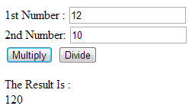
- Write a JavaScript for loop that will iterate from 0 to 15. For each iteration, it will check if the current number is odd or even, and display a message to the screen.

Sample Output :
"0 is even"
"1 is odd"
"2 is even"

- Write a JavaScript program that creates a button and add a click event listener to log a message when it's clicked.

- Use and write the correct selector to hide all odd table rows in a table.

- Find all h1 elements that are children of a div element and apply a background to them.

- Write a jQuery Code to get a single element from a selection.
Sample:
<body>
<ui>
<li>CSHARP</li>
<li>SQL</li>
<li>ADO</li>
</body>
- Write a jQuery Code to add a tag at the beginning of the list item, containing the index of the list item Sample:
<body>
<ui>
<li>CSHARP</li>
<li>SQL</li>
<li>ADO</li>
</body>.

As

0 CSHARP
1 SQ: etc..

- Append a <p> element with a text message when an <input> field is changed.

